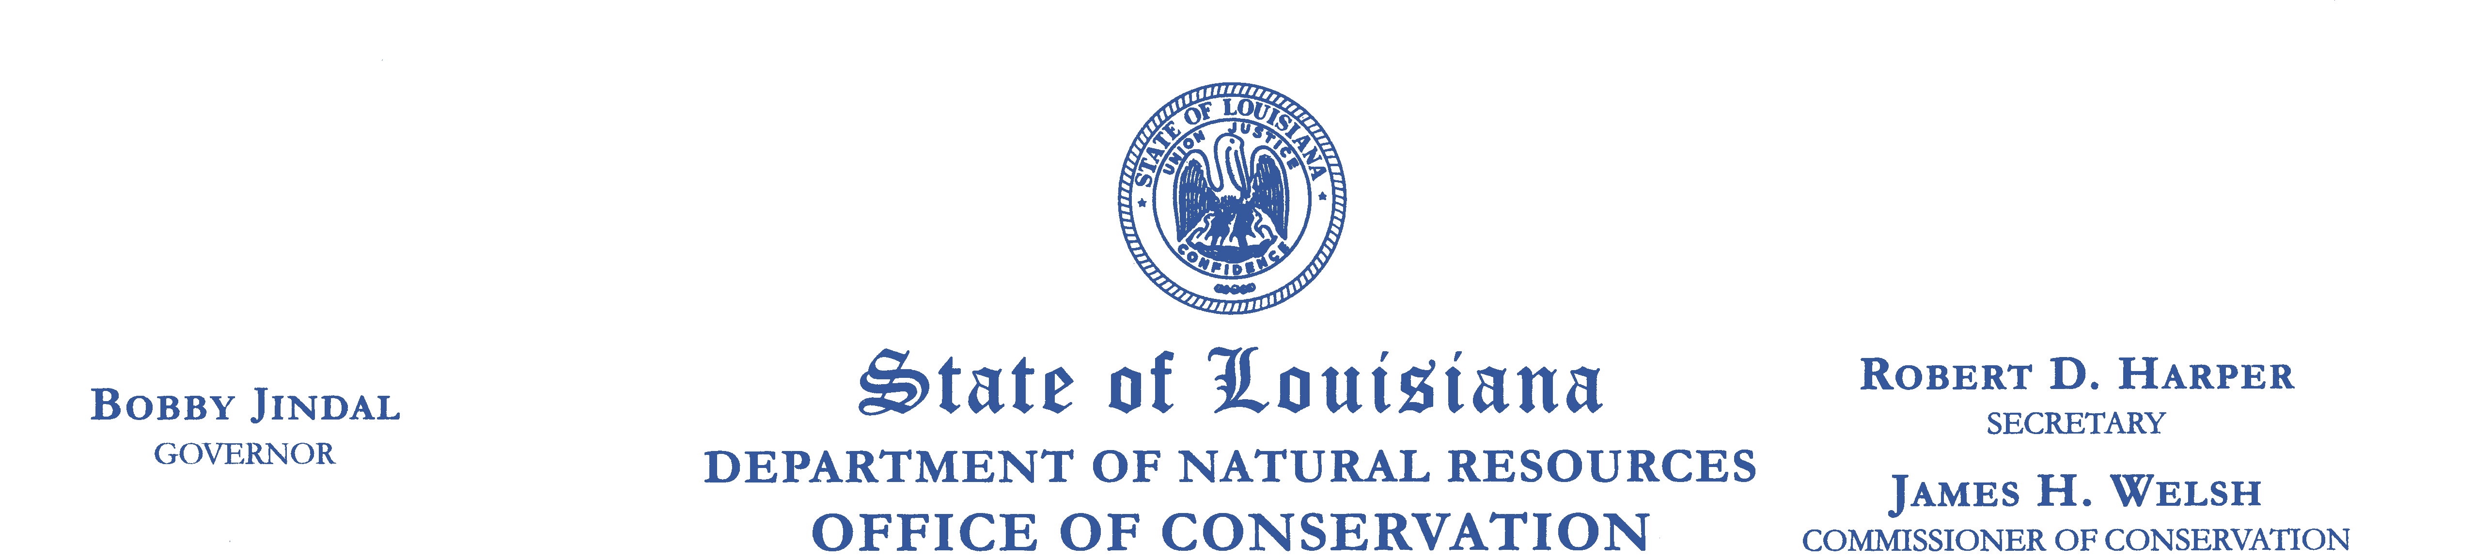
Meeting Notice:

THE ADVISORY COMMITTEE FOR THE REGULATION AND CONTROL OF
WATER WELL CONTRACTORS (DRILLERS) IN LOUISIANA WILL MEET ON:

Wednesday, August 11, 2010
1:00 P.M.

Griffon Room
LaSalle Building – 1st Floor
617 North 3rd Street
Baton Rouge, LA 70804

